October 3, 2004
Gathering Our Community

Bell Ringing
Prelude
Welcome
Announcements
Interlude
Chalice Lighting
*Opening Hymn
Building Our Community
Sharing Our Joys and Concerns
Gifts of the Congregation
*Hand of Friendship
Deepening Our Spirit
*Hymn
Program
Going Forth to Serve the World
*Hymn
*Closing Words
*Extinguishing the Chalice
*Postlude
*Indicates an invitation to stand, if able. _______________________

REV. WAUN officiates on the 1st Sunday of every month.
VISITORS please sign a visitor card in the foyer.
JOIN THIS CHURCH by supporting our principles and ministries, and signing the Membership Book in the foyer.

CALENDAR

East Suburban Unitarian Universalist Church
4326 Sardis Rd., Murrysville, PA 15668
724-327-5824 www.esuuc.org
Pastor: Renee Waun revmom@pitt.edu 412-731-2834
Religious Education Directors: Kathy & Dan Begg 412-373-4106
Music Director: Brian Ogle 724-387-1190
Choir Accompanist: Jean Robl 412-372-8972
President: Maureen McHugh 724-733-3620
Vice-President: Matt Mathis 412-654-7529
Treasurer: Cathy Serventi 724-387-1155
Secretary: Leona Dunnett 724-327-3841
Commissioned Lay Leader: Nancy Fitzgerald 412-731-2994
WE ARE A “WELCOMING CONGREGATION”

WE WELCOME YOU! This congregation of Unitarian Universalists is a beacon of liberal religion in the eastern suburbs. Part of the UU Association and the Ohio-Meadville District of the UUA, we were established in 1966, moved to this location in April of 2002 and have since been growing in numbers and visibility. If you are looking for a church home, you will find this to be an open, inclusive, friendly and engaging place for all persons, regardless of age, race, ethnicity, marital status, sexual orientation, gender expression, physical ableness, political persuasion or theological perspective. Our religious education program conforms to the highest standards for quality and relationships. Pick up a Visitor Guide from the small hymnal table, read more about us in our newsletter, found in the visitor area of the foyer, or visit our web site. We are happy you have found us!

UNITARIAN UNIVERSALISM is a non-creedal religion, with great latitude for personal beliefs. For more on Unitarian Universalist history, principles and purposes, visit the UU Association website at www.uua.org.
~~~~~~~~~~~~~~~~~~~~~~~~~~~~~~~~~~~~~~~~~~~~~~~~~~~~~

Welcome!

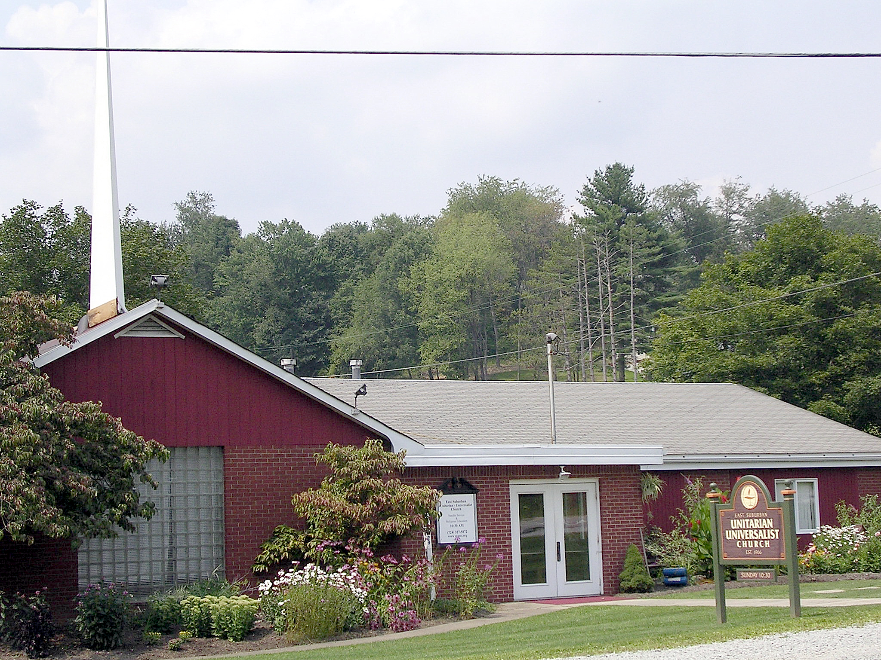

East Suburban Unitarian
Universalist Church
October 3, 2004, 10:30 a.m.

